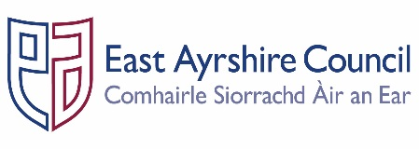
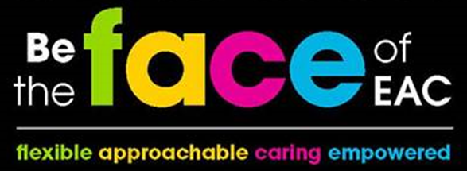
Job Outline

Post: Cleaner

Service: Safer Communities - Facilities & Property Management

Section: Asset & Facilities Support – Cleaning Operations

Grade: G1
Job Purpose: Assist with the delivery of a clean and safe user environment within various premises across East Ayrshire in order to assist with the promotion, delivery and integration of the Council’s key objectives; specifically in relation to the Community Plan, Shared Commitments, Single Outcome Agreement and Best Value.

- STRUCTURE CHART
Service Manager

Delivery Manager

FM Officer

- KEY DUTIES & RESPONSIBILITIES

- Carry out a range of planned and unplanned cleaning activities throughout the premises in accordance with the agreed satisfaction standards.

- Carry out a range of cleaning activities ensuring that all areas are clean and operational safe and fit for use established procedures, agreed guidelines, risk assessments and regulations.

- Undertake various cleaning activities including sweeping, vacuuming and mopping floors and dusting, damp wiping, washing and polishing all other surfaces and fittings as directed.

- Undertake the cleaning of a planned allocated area of the premises including toilets and changing areas, as instructed.

- Assist with any un-planned cleaning requirements as instructed.

- Utilise a range of cleaning equipment in order to carry out the duties of the post ensuring these are operated, maintained in accordance with the manufacturer instructions and securely stored after use.

- Undertake all cleaning activities ensuring the safe and proper use of chemicals and cleaning materials in accordance with Health and Safety legislation and COSHH guidance.

- Replenish toilet and wet areas with sufficient supplies i.e. paper towels, toilet rolls, soap dispensers as required ensuring any shortages are communicated to the Facilities Assistant.

- Report any incidents involving colleagues, premise users and visitors to the Facilities Assistant or Facilities Co-ordinator.

- Attend team meetings and participate in relevant employee training sessions required to undertake the duties and responsibilities of the post.

- GENERAL RESPONSIBILITIES

- Ensure that any materials and equipment provided to assist in carrying out the duties of the post are properly secured in accordance with the Council’s policies and procedures.

- Ensure that the Council’s Customer First Service Commitment is followed in all dealings with the customers and clients of the Service.

- Ensure that all activities for which the post-holder is responsible are delivered in accordance with the Council`s Equal Opportunities Policy and its statutory and general and specific Equality Duties.

- Promote the health and safety of employees at work and of service users through the implementation of the Council’s policy on health, safety and welfare at work and Service Health and Safety arrangements in accordance with all relevant statutory requirements.

- Participate in the East Ayrshire General Employee Review (EAGER) process annually in accordance with the Council’s guidelines.

- Adhere to the Councils’ policies and procedures for good records management ensuring that the correct information is created, maintained, stored and retrieved in accordance with business need and statutory and legislative requirements.

Person Specification
Designation: Cleaner | Post No: Various
Service: Facilities & Property Management | Section: Cleaning Operations

Attributes: | Essential Criteria | Desirable
Qualifications
Knowledge & Skills | - Able to take instruction and direction  - Ability to work in an organised and methodical manner  - Ability to complete basis paperwork  - Literacy and numeracy skills. | - Knowledge of COSHH legislation  - Knowledge of Health and Safety legislation in relation to work undertaken
Experience | - Cleaning experience (e.g. sweeping, mopping, vacuuming etc) | - Used a range of commercial cleaning tools (i.e. buffing machinery)  - Experience of providing cleaning duties in a commercial environment
Employees are the FACE of East Ayrshire and are expected to demonstrate our FACE qualities and behaviours
Quality | Behaviour
Flexible | - Have an open mind and look for better ways of doing things.  - Embrace new technologies to improve services for the people we serve.  - Welcome opportunities to learn and grow.
Approachable | - Develop positive and productive relationships with everyone.  - Listen, notice, respond and engage.  - Manage our reactions and think about how our behaviour affects others.
Caring | - Embrace working in a team and working with others.  - Take pride in your role, serving our community and strive to be the best we can be.  - Be kind to others and to ourselves.
Empowered | - Have the courage to try new things.  - Work with others to find the best solutions.  - Help everyone to realise their full potential.

