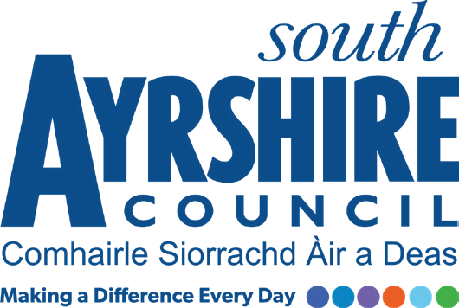
Job Title Health & Fitness Instructor (Health)

Level Level 5

Service Sport & Leisure

Job Purpose

Under the direction of the Health & Fitness Officer deliver a range of health referral-based classes, inductions and health assessments.

Date: May 2022
Job Description

Post Responsibilities:
- Deliver and instruct classes for a range of Health Referral exercise programmes ensuring the safety and welfare of participants at all times.

- Compile class registers, prepare teaching plans and monitor participant progress

- Provide bespoke assessments and inductions to triage customer suitability to attend specialist programmes and activities as part of the wider Activity for Health scheme.

- Assist in the delivery of a health and fitness programmes in accordance with set guidelines and standards

- Ability to meet targets in accordance with set timescales

- Operate online booking system and process sales ensuring the administration of the service is both effective and efficient

- Apply and adhere to council policies and procedures

- Ensure adherence to relevant legislation, external policy and safe practices

- Continually monitor and evaluate practices to ensure quality service provision and service improvement

- Ensure information and advice is communicated in a clear, concise and accurate manner through written and verbal communication

- Contribute to service improvement to ensure a best value, customer focussed approach to service delivery

Possession of:
- Essential - NVQ Level 2 Exercise to music, gym instructor qualification or equivalent with
- Desirable - NVQ Level 3 Exercise Referral qualification or NVQ Level 4 Health qualification - Cardiac, PSI, Stroke, CanRehab

Substantiated ability to:

- Maintain as valid, the minimum qualifications for the post at all times during the period of employment

- Have the willingness to undertake additional training in line with the required Health qualifications to ensure service delivery

- Work evenings and weekends as required

- Meet the standards of performance required under the Values and Behaviours of South Ayrshire Council

- To travel efficiently and effectively between various work locations

Demonstrable experience of:

- Delivering exercise classes to groups with post qualification experience through mentoring or direct delivery being desirable

• Excellent written and verbal communication skills

• An ability to work on own initiative but also as part of a team

• Being responsive to the needs and demands of customers

• Good organisational skills with the ability to manage own workload

- An awareness of Health and Safety in the workplace, moving and handling training, experience of working in a demanding environment, meeting targets and deadlines, an ability to motivate self and others within the team and to lead and direct sports participants and willingness to provide mentoring and support to newly qualified coaches all being desirable

In terms of the Protection of Vulnerable Groups (Scotland) Act 2007, this post is designated as
Regulated Work. Consequently, in order to undertake the duties of this post, you must hold
Membership of the Protecting Vulnerable Groups (PVG) Scheme.

If you are charged with any offence, or are involved in any activity which may have implications
For your membership of the PVG Scheme, you must immediately notify your Line Manager.

Applicants must be able to recognise and report concerns about the wellbeing of children and vulnerable service users and be able to maintain appropriate professional relationships with service users.

