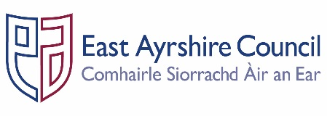
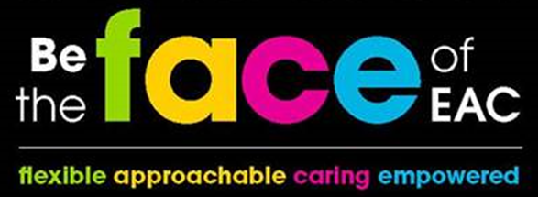

Job Outline

Post: | Modern Apprentice – Catering
Service: | Communities and Economy
Section: | Food and Facilities
Grade: | MA
Job Purpose: | Provide support to individuals in a catering setting and to undertake Professional Cook SVQ Modern Apprentice Programme

A. | Structure Chart

Line Manager

Modern Apprentice

B. | Functional Responsibilities

- You will be required to assist in preparing, cooking and clearing food for large numbers.

- Planning and preparation of meals

- Responsible for safe working practices within the kitchen

- Participation, as part of the team

C. | General Responsibilities

- Ensure that any materials and equipment provided to assist in carrying out the duties of the post are properly secured in accordance with the Council’s policies and procedures.

- Ensure that the Council’s Customer First Service Commitment is followed in all dealings with the customers and clients of the Service.

- Ensure that all activities for which the postholder is responsible are delivered in accordance with the Council`s Equal Opportunities Policy and its statutory and general and specific Equality Duties.

- Promote the health and safety of employees at work and of service users through the implementation of the Council’s policy on health, safety and welfare at work and departmental Health and Safety arrangements in accordance with all relevant statutory requirements.

- Participate in the East Ayrshire General Employee Review (EAGER) process annually in accordance with the Council’s procedures.

PERSON SPECIFICATION

Designation: Modern Apprentice - Catering |  | Post No:
Service: Communities and Economy |  | Section: Food and Facilities
Attributes: | Essential Criteria | Desirable
Qualifications |  | - Food Hygiene Certificate
Knowledge & Skills | - Able to take instruction and direction.  - Able to work with supervision or as part of team.  - Trustworthy.  - Pleasant personality.  - Good communication skills. | - Awareness of duties included within catering environment
Experience |  | - Experience in a catering environment

Employees are the FACE of East Ayrshire and are expected to demonstrate our FACE qualities and behaviours

Quality | Behaviour
Flexible | - Have an open mind and look for better ways of doing things.  - Embrace new technologies to improve services for the people we serve.  - Welcome opportunities to learn and grow.
Approachable | - Develop positive and productive relationships with everyone.  - Listen, notice, respond and engage.  - Manage our reactions and think about how our behaviour affects others.
Caring | - Embrace working in a team and working with others.  - Take pride in your role, serving our community and strive to be the best we can be.  - Be kind to others and to ourselves.
Empowered | - Have the courage to try new things.  - Work with others to find the best solutions.  - Help everyone to realise their full potential.

