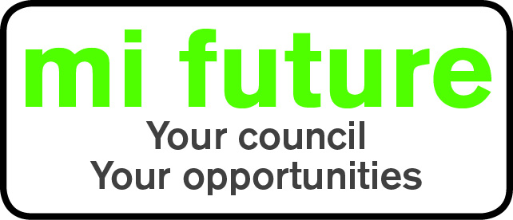

Generic Role Strengths Profile – C7

Midlothian Council has adopted a behavioural style of interviewing. Our interviews are structured and are strengths based, that is we search for a number of characteristics or skills, that we have identified as being important for success in the role in question.
Below are the strengths identified for the post you are applying for: -

Strengths for Matching

Persuasive - Is comfortable negotiating and likes to influence other people’s views.

Controlling - Likes to be in charge, take the lead in stations and tell others what to do.

Socially Confident - Feels comfortable when first meeting people and is at ease in formal settings

Behavioural - Enjoys analysing people likes to understand their motives and behaviour.

Evaluative - Evaluates information, identifying potential limitations or errors.

Innovative – Enjoys generating new ideas, being creative, and thinks of original solutions.

