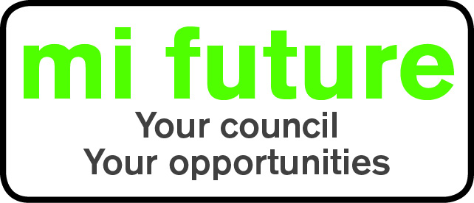

Generic Role Profile Strengths – C2

Midlothian Council has adopted a behavioural style of interviewing. Our interviews are structured and are strengths based, that is we search for a number of characteristics or skills, that we have identified as being important for success in the role in question.
Below are the strengths identified for the post you are applying for:-

Strengths for Matching

Behavioural - Enjoys analysing people likes to understand their motives and behaviour.

Caring – Tends to be sympathetic, considerate, helpful and supportive of others.

Relaxed –Finds it to relax, unwind after work and generally remain calm and untroubled.

Socially Confident - Feels comfortable when first meeting people and is at ease in formal settings.

Rule Following - Follows rules and regulations, prefers clear guidelines.

Conscientious –Focuses on getting things finished and persists until the job is done.

Vigorous – Thrives on activity, and enjoys having a lot to do.

