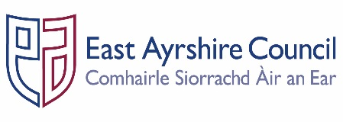
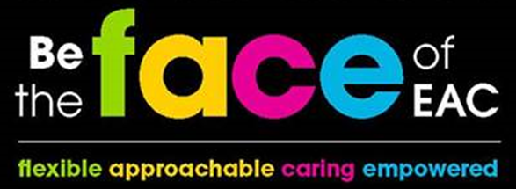

Job Outline

Post: Graduate Internship

Service: Various

Section: Various

Grade: SLW

Job Purpose: Provide dedicated project support to Services across East Ayrshire Council within a learning contract in order to assist with the promotion, delivery and integration of the key objectives in relation to those identified within the relevant Service Plan and the Community Plan.

- STRUCTURE CHART

- KEY DUTIES & RESPONSIBILITIES

- Assist in developing project plans, undertake actions, coordinate, monitor and evaluate the delivery of the projects.

- Work with other Partnership, Council and external services as required to research, engage/consult and communicate regarding the projects.

- Create documents, reports and work with management information and performance data to support the projects.

- Provide dedicated project management support working to project management principles in the delivery of a nominated project, implementing agreed objectives, monitoring, reviewing and reporting progress and ensuring all timescales are adhered to.

- Support the employing Service to deliver key outcomes identified in their Service Plans, linked to the delivery of the nominated project.

- Participate in the Internship Programme to ensure that training and employment needs are met, attending relevant learning and development events and meetings as required.

- Assist with the production of a project plan for the nominated project and implement the delivery, monitoring and reviewing of the dedicated project.

- Gather, analyse, record and use data to ensure the project is evidence based.

- Use a range of software packages, including Microsoft Office, to produce reports, design and maintain spreadsheets, databases and other management information systems in accordance with the Data Protection Act.

- Communicate with key stakeholders to ensure all relevant interests are met ensuring a professional approach when dealing with all customers and clients in accordance with the principles of good customer care.

- Assist in the development of procedures to assist in the effective delivery of project objectives as agreed with relevant manager.

- Ensure that all work is completed to prescribed deadlines and provide regular progress reports to the line manager.

- GENERAL RESPONSIBILITIES

- Ensure all materials and equipment provided to assist in carrying out the duties of the post are properly secured in accordance with the Partnership’s policies and procedures.

- Promote the health and safety of employees at work and of service users through the implementation of the Partnership’s policy on health, safety and welfare at work and Service Health and Safety arrangements in accordance with all relevant statutory requirements, leading by example.

- Ensure all activities for which the post holder is responsible are delivered in accordance with Council’s Equality and Diversity Policies and the statutory and general specific Equality Duties.

- Ensure that the Council’s Customer Service Commitment is followed in all dealings with the people we serve.

- Adhere to the relevant service policies and procedures for good records management across the Services, ensuring that the correct information is created, maintained, stored and retrieved in accordance with business need and statutory and legislative requirements.

- Participate in the East Ayrshire FACE Time review process in accordance with the Council’s procedures and participate in further training and learning opportunities as required within the post.

Person Specification

Designation: Graduate Intern | Post No:
Service: Various | Section: Various

Attributes: | Essential Criteria | Desirable
Qualifications | - HNC in relevant topic or related discipline | - HND or Degree in relevant topic or related discipline
Knowledge & Skills | - Good written and verbal communication skills.  - Ability to produce accurate work with a strong attention to detail.  - Good interpersonal skills.  - Strong organisational and planning skills.  - Ability to work to prescribed deadlines.  - Knowledge of IT systems  - Proactive with a “can do” approach.  - Reliable with a strong sense of commitment.  - Ability to engage effectively with colleagues.  - Ability to work on your own initiative or as part of a team.  - Understanding of digital technology. | - An understanding of Local Government Services.  - Creative thinker.  - Good analytical and problem solving skills.  - Able to work independently with minimum supervision.
Experience | - Experience of using a range Microsoft Office packages including Word, Excel and Outlook. | - Experience of working in a customer focused environment.
Employees are the FACE of East Ayrshire and are expected to demonstrate our FACE qualities and behaviours
Quality | Behaviour
Flexible | - Have an open mind and look for better ways of doing things.  - Embrace new technologies to improve services for the people we serve.  - Welcome opportunities to learn and grow.
Approachable | - Develop positive and productive relationships with everyone.  - Listen, notice, respond and engage.  - Manage our reactions and think about how our behaviour affects others.
Caring | - Embrace working in a team and working with others.  - Take pride in your role, serving our community and strive to be the best we can be.  - Be kind to others and to ourselves.
Empowered | - Have the courage to try new things.  - Work with others to find the best solutions.  - Help everyone to realise their full potential.

