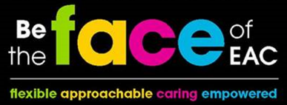
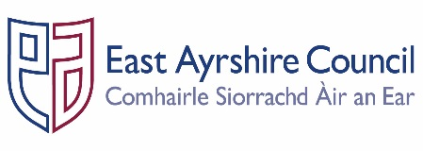
JOB OUTLINE

Post: Modern Apprentice – Vibrant Communities Youth Worker

Service: Housing & Communities

Section: Supporting Vibrant Communities

Grade: MA
Job Purpose: Provide administrative and play related support service in order to assist with the promotion, delivery and integration of the Communities & Economy Service plan.

- SECTION STRUCTURE CHART
Line Manager

Modern Apprentice

- KEY DUTIES & RESPONSIBILITIES

- Provide administrative and support functions within the team, to assist in delivering youth work activities in line with priorities and strategic plans, including word processing, photocopying, session planning and other related tasks.

- Ensure safe use, operation, cleaning and maintenance of resources and equipment.

- Assist with the delivery of a range of youth work related activities and training, keeping people at the heart of everything we do.

- Develop and maintain good working relations with colleagues throughout Vibrant Communities, the wider Housing & Communities Services and other agencies/departments.

- GENERAL RESPONSIBILITIES

- Ensure all materials and equipment provided to assist in carrying out the duties of the post are properly secured in accordance with Vibrant Communities’ policies and procedures.

- Promote the health and safety of employees at work and of service users through the implementation of the Council’s policy on health, safety and welfare at work and Service Health and Safety arrangements in accordance with all relevant statutory requirements, leading by example.

- Ensure all activities for which the post holder is responsible are delivered in accordance with Council’s Equality and Diversity Policies and the statutory and general specific Equality Duties.

- Ensure that the Council’s Customer Charter is followed in all dealings with the people we serve.

- Adhere to the Council’s policies and procedures for good records management across the Services, ensuring that the correct information is created, maintained, stored and retrieved in accordance with business need and statutory and legislative requirements.

- Participate in the East Ayrshire FACE Time review process annually in accordance with the Council’s procedures.

- Participate in the modern apprentice programme to ensure that training and employment needs are met and complete SVQ 3 qualification.

- Commit to undertaking the Council’s mandatory and subject specific training to improve your knowledge, awareness and your own CPD.

- Work within a flexible working environment across East Ayrshire, including evening and weekend work.

PERSON SPECIFICATION
Designation: Modern Apprentice – Vibrant Communities | Post No:
Service: Housing & Communities | Section: Supporting Vibrant Communities

Attributes: | Essential Criteria | Desirable
Qualifications
Knowledge & Skills | - Ability to follow instructions and take direction  - Able to work as part of a team or own with supervision | - Awareness of staff roles & responsibilities within a youth work environment  - Awareness of the National Youth Work Outcomes  - Awareness of Youth Work Network and Strategic Partners  - Ability to engage with children, young people & adults  - Literacy & numeracy skills
Experience |  | - Participated in the delivery of Play/health/physical activity/youth work programmes  - Experience of using ICT  - Reporting and undertaking evaluations with service users and partners  - An interest in working in a youth work environment

Employees are the FACE of East Ayrshire and are expected to demonstrate our FACE qualities and behaviours

Quality | Behaviour
Flexible | - Have an open mind and look for better ways of doing things.  - Embrace new technologies to improve services for the people we serve.  - Welcome opportunities to learn and grow.
Approachable | - Develop positive and productive relationships with everyone.  - Listen, notice, respond and engage.  - Manage our reactions and think about how our behaviour affects others.
Caring | - Embrace working in a team and working with others.  - Take pride in your role, serving our community and strive to be the best we can be.  - Be kind to others and to ourselves.
Empowered | - Have the courage to try new things.  - Work with others to find the best solutions.  - Help everyone to realise their full potential.

