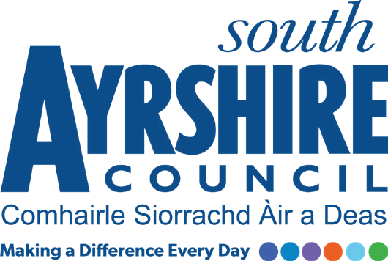

Job Purpose

Undertake normally as part of a team, the cleaning of a designated area within school/ council premises to ensure that they are kept in a clean and hygienic condition.

Date: October 2021
Job Title Cleaner (General) Term Time

Level Level 1

Service Facilities Management

Job Description

Post Responsibilities:
- Cleaning, washing, sweeping, vacuum cleaning, emptying of litter bins, polishing and dusting of designated areas.
- Using powered equipment where necessary.
- Usage of council approved cleaning materials.
- To carry out such other duties consistent with the post as directed by the Cleaning Supervisor

Possession of:
- Basic knowledge and awareness of Health and Safety Working practices
- Ability to work either as a team member or lone worker, as required
- Good health, mobility and physical fitness.

Substantiated ability to:
- Demonstrate relevant work experience relative to the role
- Articulate with good manners and a willingness to help others
- Work with limited supervision to deliver quality standards
- Meet the standards required under the Values and Behaviours of South Ayrshire Council

Demonstrable experience of:
- Manual Handling skills and experience
- Reliability and enthusiasm
- Working and adapting within a flexible working environment with the ability to cover various locations across South Ayrshire Council as and when required including weekends
- Customer care

In terms of the Protection of Vulnerable Groups (Scotland) Act 2007, this post is designated as
Regulated Work. Consequently, in order to undertake the duties of this post, you must hold
Membership of the Protecting Vulnerable Groups (PVG) Scheme.

If you are charged with any offence, or are involved in any activity which may have implications
For your membership of the PVG Scheme, you must immediately notify your Line Manager.

Applicants must be able to recognise and report concerns about the wellbeing of children and vulnerable service users and be able to maintain appropriate professional relationships with service users.

