Candidate Information

Network Delivery Coordinator

Salary: | Grade G: £28,499-£33,918 per annum
Hours: | 37.5 hours per week  This job is proposed to be full-time but we are happy to discuss working hours and patterns to suit individual circumstances. Job share options may be considered.
Contract: | Permanent
Disclosure: | PVG Scheme is not required for this position
Base: | Sustrans office in Edinburgh with the flexibility to work from home, or home-based within reasonable travelling distance from Edinburgh or Glasgow.
Travel: | This role will involve regular travel most weeks. We may occasionally need you to travel further during the course of your work including occasional overnights stays.
 | A key part of being the Charity that makes it easier to walk and cycle is that most colleagues cycle, walk, wheel or use public transport for the majority of their work journeys. We support this with access to a Sustrans pool bicycle and National Standards Cycling Training.

Job or Project Specific Information

This is an exciting opportunity to make a difference by directly tackling the barriers that prevent people from travelling more actively and sustainably. You will be part of our Network Development Team, delivering Sustrans’ ’Paths for Everyone’ vision of a network of traffic-free paths for everyone, connecting cities, towns and countryside, loved by the communities they serve.

The postholder will develop and manage a range of infrastructure projects across Scotland in partnership with communities, volunteers, local authorities and other public and third sector agencies, ensuring year on year delivery of our programme. We encourage the team to go out regularly to visit projects or sections of the network requiring improvement.

We enjoy working and growing together as a team, and value the contribution and expertise of all members. We will support you to find a work-life balance that best meets your needs and provide professional development opportunities.

Here are some projects we have been involved in delivering:

Loanhead path extension:
https://www.showcase-sustrans.org.uk/news/midlothian-cycle-link/

Monklands Canal towpath surfacing:
https://www.sustrans.org.uk/our-blog/news/2022/march/work-begins-on-429-000-improvements-to-national-cycle-network-route-75-in-north-lanarkshire/

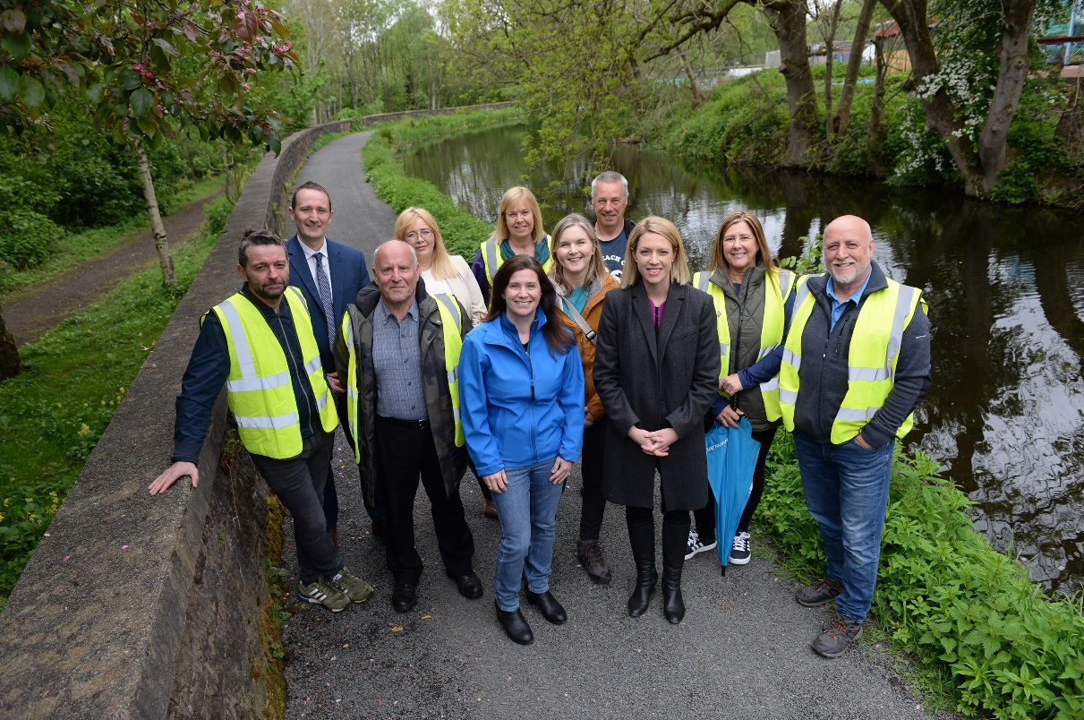

Where this role sits in our team:

Meet the team!
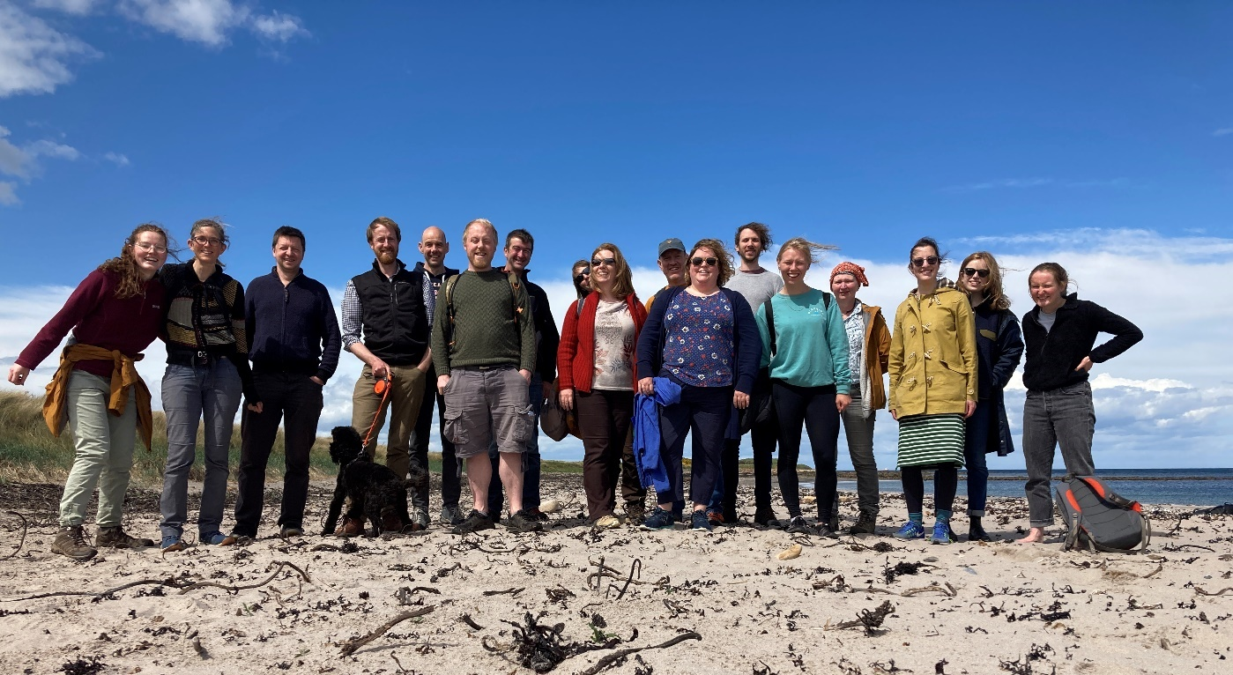

Job Description - About the Role

Overview

The purpose of this role is to lead on the development and delivery of active travel projects, creating a national network of walking, wheeling and cycling infrastructure that is accessible to, and benefits, everyone. You will be part of a positive and supportive team, driven by a passion to find creative solutions to the challenges of improving active travel infrastructure.
An important element of the role will be to manage relationships with partner organisations and identify opportunities to deliver projects that contribute to Sustrans’ ’Paths for Everyone’ vision. You will also have the opportunity to commission projects and manage grant funding for project partners.
The postholder work closely with other members of the team and with colleagues in other Sustrans teams including Places for Everyone, Volunteering and Land & Estates.

Where this role sits in the structure | Reporting to the Network Delivery Manager (Scotland);  Working closely with the Strategic Network Development Manager, the Network Engagement Manager and the other Network Delivery Coordinators and Project Officers.  This role does not currently have line management responsibility but this is envisaged as the team grows.

Key Responsibilities

- Lead on the development and delivery of infrastructure projects which contribute to Sustrans’ Paths for Everyone vision in Scotland.
- Manage grants to partner organisations and monitor delivery of the associated work.
- Commission and manage project work packages to both internal and external consultancies.
- Manage and develop partner and stakeholder relationships.
- Manage project / programme budgets.
- Support the development and updating of our Network Plan database as a tool for planning delivery and reporting progress.
- Ensure cross-programme expertise is utilised, such as ecology, volunteering and community engagement to support successful delivery outcomes.
- Assist in the monitoring and evaluation of projects in conjunction with our Research and Monitoring Unit.
- Respond to enquiries.
- Contribute towards raising the profile of Sustrans, by representing the charity at conferences, meetings, activities and events, as required.

We don’t expect anyone to be an expert in all these areas and as long as you meet the person specification we can train you in any gaps.

Person Specification
The following criteria sets out the method by which the skills, knowledge and experience will be assessed against. Our website has a useful guide about how to make a great job application.

 | Application Form | Interview
Specific experience required
Relevant experience of working within transport, transport consultancy or construction sector | x | x
Experience of project management and delivery | x | x
Experience of successful partnership working | x | x
Experience working with consultants and/or contractors | x | x
Skills and Abilities
Good organisational skills (including time management skills)
Ability to analyse and critique reports written by others | x
Excellent problem-solving skills; ability to work independently and make decisions with minimal supervision |  | x
Excellent stakeholder engagement skills; ability to build relationships with project partners, community groups and the general public; ability to persuade stakeholders | x | x
Strong communication skills (including presentation, written and verbal/interpersonal) |  | x
Specific knowledge required
Good knowledge of local and regional transport planning authorities and processes (Scotland) | x
Good knowledge of transport and active travel infrastructure delivery and best practise | x

This document does not form part of the contract of employment but does outline our expectations.
If we need to amend this document in the future we will consult with the post holder before doing so.

Everyone at Sustrans

Our values guide us in everything we do:
- Including everyone
- Having the courage to question
- Acting local, thinking big
- Getting things done, together
- Always learning.

- Sustrans has clear health and safety policies and it is essential that all our colleagues follow these. Very often our teams come into contact with young people through schools work or community engagement so it is everyone’s responsibility at Sustrans to comply with our Safeguarding policies.

- One of our key strategic goals is to be a charity “for everyone”, building a more diverse and inclusive Sustrans. We recognise there is much more we can do to bring together diverse life experiences and voices to enable us to more fully understand, access and represent the communities we work in. Everyone at Sustrans should support this goal and follow our Equality, Diversity and Inclusion policies and procedures.

- Sustrans asks that all our employees develop their skills, knowledge and experience through training and personal development activities. Sustrans will support you with clear objectives and a supportive management culture - our teams tell us that one of the great things about working for Sustrans is the learning and knowledge sharing opportunities.

- It is very important that our colleagues are happy and able to work with IT systems - we use Microsoft programmes and other databases every day (we will train you on our bespoke systems).

- It is also important that everyone at Sustrans supports and follows with the charity’s guidance on branding/key messages and contributes towards raising Sustrans’ profile.

- Everyone at Sustrans is required to work their contracted hours and record their time – if extra hours are worked then we can take time off in lieu.

- We ask that everyone in Sustrans helps us to develop new opportunities for funded work and builds excellent relationships with our delivery partners and stakeholders.

- Two of our values are we get things done, together and we’re always learning. Managers often require their teams to get involved in activities that are outside of their job descriptions as we feel this is one of the ways you can learn on the job, develop new skills, make new contacts and progress your career with Sustrans.

