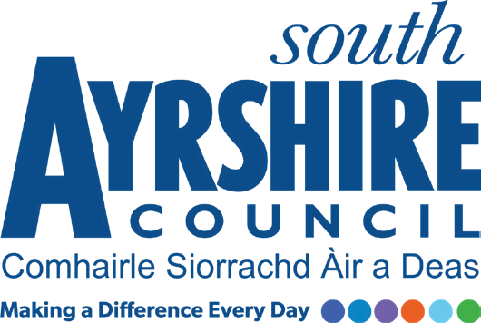

Job Purpose

To train as a Youth Work Modern Apprentice and develop the required level of skills, knowledge, experience and competence during the 12 month apprenticeship programme. To ensure that expected levels of performance on the job and through vocational studies are maintained throughout the apprenticeship.

Date: December 2021
Job Title Youth Work Modern Apprentice

Level MA Grade

Service Employability & Skills / Community Learning & Development

Job Description

Post Responsibilities:
- Assist Youth Work staff in the communities and in schools.
- To apply and adhere to all council policies and procedures.
- To understand and apply the relevant processes and procedures for the post.
- Ensure adherence to relevant legislation, external policy and safe practices.
- To be aware of and apply relevant customer service standards.
- Ensure information and advice is communicated in a clear, concise and accurate manner through written and verbal communication.
- To produce accurate work and meet targets in accordance with set timescales.
- To develop new skills and gain knowledge and experience through the training programme
- Attend all training and development activities as required, and complete all necessary studies to achieve a Scottish Vocational Qualification.
- Support youth initiatives and projects as directed by your line manager.
- To ensure a high standard of service delivery at all times.
- Contribute to a positive and inclusive working environment within which regular performance review takes place and to undertake further training as appropriate.
- Ensure safe working practices in which the health, safety and welfare of colleagues are not compromised.
- To carry out such other duties consistent with the post as may be required by your Employability and Skills Officer/Supervisor.

Substantiated ability to:
- Complete an SVQ level 2
- Work with young people.
- Work as part of a team with other youth work staff.
- Prioritise your workload and meet deadlines.
- Meet the standards required under the Values and Behaviours of South Ayrshire Council

Demonstrable experience of:
- Good written and verbal communication skills
- Accuracy with a strong attention to detail
- Organised and reliable with a strong sense of commitment
- Good customer service awareness

Proven Technical Understanding of:
- Candidates must display an interest in working with young people.

