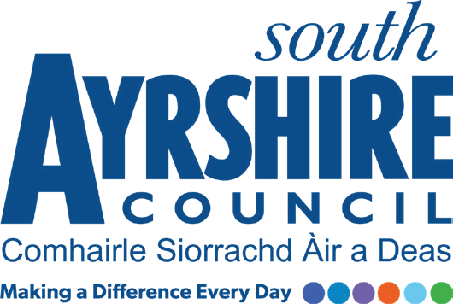

Job Purpose

To ensure the well-being of residents by maintaining recognised standards of both care and practice within the unit.

Date: May 2018
Job Title Social Care Worker

Level 5

Service Health and Social Care Partnership

Job Description

Post Responsibilities:

To ensure the pursuance of the aims and objectives of the establishment upholding the Residents Charter and in doing so support individuals in achieving their maximum respective independence within the context of a safe, supportive and homely environment in accordance with the National Care Standards.

To engage in direct personal caring duties with residents to ensure that their needs are appropriately met supporting adults with a learning disability.

To be involved in the formulation, implementation and review of respective Personal Centred Plans as appropriate to this post and furthermore to assist in the production and subsequent presentation of these reports at case reviews etc.

To participate in on-going training as directed for the maintenance and development of relevant skills for the proper delivery of the duties of a Social Care Worker.

Possession of:

SVQ 2 in Social Care or relevant experience and ability to work towards attaining an SVQ 3 in Social Care or equivalent and ability to meet current and future registration requirements of the SSSC.

Meet the standards of performance required under South Ayrshire Council’s Values and Behaviours

Substantiated ability to:

Communicate effectively using both written and verbal forms of communication

Previous knowledge/experience of providing personal care.
Must be able to demonstrate experience in working with vulnerable and challenging groups and the ability to deal with diverse situations.

Demonstrable experience of:

Genuine empathy and concern for vulnerable people and the ability to adapt communication skills as appropriate to the person.
An awareness of Health & Safety in the workplace
Must be able to demonstrate an ability to work on own initiative but also as part of a team.

Applicant must be able to recognise and report concerns about the well-being of children and vulnerable people.

Proven Technical Understanding of:

Good computer and ICT skills

In terms of the Protection of Vulnerable Groups (Scotland) Act 2007, this post is designated as
Regulated Work. Consequently, in order to undertake the duties of this post, you must hold
Membership of the Protecting Vulnerable Groups (PVG) Scheme.

If you are charged with any offence, or are involved in any activity which may have implications
For your membership of the PVG Scheme, you must immediately notify your Line Manager.

Applicants must be able to recognise and report concerns about the wellbeing of children and vulnerable service users and be able to maintain appropriate professional relationships with service users.

