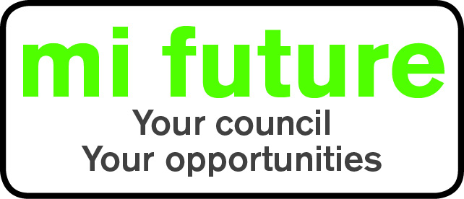

Generic Role Profile Strengths - Pro (2)

Midlothian Council has adopted a behavioural style of interviewing. Our interviews are structured and are strengths based, that is we search for a number of characteristics or skills, that we have identified as being important for success in the role in question.

Below are the strengths identified for the post you are applying for:-

Strengths for Matching

Persuasive - Is comfortable negotiating and likes to influence other people’s views.

Democratic – Likes to consult and involve others, making sure everyone has a say before making a decision.

Evaluative – Evaluates information, identifying potential limitations or errors

Conscientious – Focuses on getting things finished, persists until the job is done

Trusting – Wary of others intentions and unlikely to be fooled by people

Vigorous – Thrives on activity, and enjoys having a lot to do.

