Leisure Attendant & Recreation Attendant - Outdoor Facilities

The Package

Lewis



**Lisanne MacInnes, Leisure Attendant & Move More Activity Officer**

‘Working in a leisure centre has enabled me to increase my learning with further course qualifications and encouraged me to push myself in my career. I thoroughly enjoying working with colleagues and getting to know members and Move More participants’

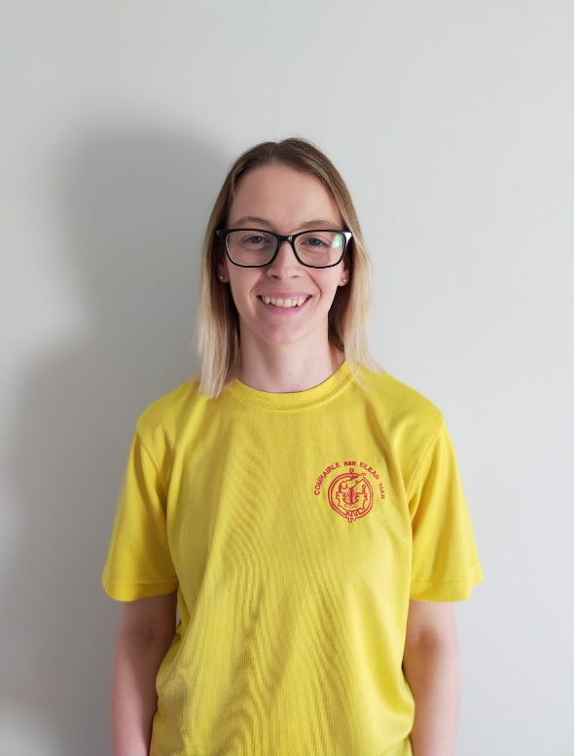

* *£10.34 - £10.48 per hour plus £1.24 per hour Distant Islands Allowance, appointment on first point of grade*
* *16.5 hours per week*
* *Permanent*
* *Local Government Pension Scheme*
* *34 days annual leave, inclusive of Public Holidays (pro rata) per annum*
* *Generous Maternity & Sick Pay Benefits*
* *Employee Assistance Programme*

The postholder will undertake maintenance tasks, facility supervision and a range of coaching activities dependent on experience, qualifications held or training provided by CnES.

Job Purpose

**Job Title:** Leisure & Recreation Attendant – Outdoor Facilities

**Job Number:** 5962

**Department:** Education, Skills & Children’s Services

**Grade:** C

**Location:** Ionad Spòrs Leòdhais

**Date:** 2022

**Responsible to:** Director for Education, Skills & Children’s Services; in the first instance to the Sports Facilities Services Manager

# Leisure & Recreation Attendant – Outdoor Facilities

# Duties

1. Supervise users to ensure safe operation of facility.
2. Offer immediate First Aid in line with training and qualifications held.
3. Undertake facility maintenance tasks.
4. Operate the till and handle cash.
5. Answer enquiries on the phone, take bookings for facilities.
6. The ability to work flexibly, including evenings and weekends.
7. Carry out cleaning and maintenance duties in toilets and changing areas, grass pitch, all weather suface and athletics track area etc in line with training and qualifications held.
8. Assist with coaching and teaching in line with training provided or qualifications held.

**General Accountabilities**

1. To ensure that all information received and disseminated, whether verbal, written or electronic concerning all employees, prospective employees or service users is treated in the strictest confidence and that all such information held is regulated and controlled in a similar manner in compliance with Data Protection legislation.
2. To ensure that all duties and responsibilities are performed in a safe manner so that no risk to health and safety arises to yourself, any other employee or member of the public.
3. As the Comhairle is committed to the effective management of risk, it is the responsibility of all employees to carry out their duties and responsibilities with adequate regard for Risk Management as outlined within the Comhairle’s Risk Management Policy.
4. To comply with the Comhairle’s Equal Opportunity Policy in Service Delivery and Employment, thereby promoting a fair and quality service to all.
5. To keep under review your own development needs. Learning needs should be discussed and determined at your annual Performance Appraisal and you will be required to undertake training as identified and as appropriate and required for the effective performance of the duties of the post.
6. Any other duties or responsibilities that may be need to be allocated from time to time to ensure the efficiency of the service.



**COMHAIRLE NAN EILEAN SIAR**

**PERSON SPECIFICATION**

THIS FORM LISTS THE ESSENTIAL AND DESIRABLE CRITERIA REQUIRED. APPLICANTS WILL BE LEETED ON THE BASIS OF MEETING THE CRITERIA. PLEASE ENSURE YOU COMPLETE YOUR APPLICATION FORM CONSIDERING THE CRITERIA BELOW.

|  |  |  |  |
| --- | --- | --- | --- |
| **post title:** | Leisure Attendant – Outdoor Facilities | **post number:** |  |

|  |  |  |  |  |
| --- | --- | --- | --- | --- |
| **CRITERIA** |  | **ESSENTIAL** |  | **DESIRABLE** |
| Knowledge | E1 | Knowledge of Microsoft Office products | D1 | Operation of computer based booking systems and cash handling |
| Skills and Abilities | E2  E3  E4  E5  E6  E7 | Understanding of customer based service  Well developed communication skills with adults and children.  Ability to operate light machinery or willingness to undertake training  Demonstrate capacity to work on own initiative whilst also following written/verbal guidelines and procedures  Ability to undertake a range of maintenance tasks  Ability to undertake a professional approach to a range of activities and services | D2  D3 | Evidence of work in a customer facing environment including taking phone calls and operation of booking systems  Evidence of small scale repair and maintenance skills |
| Education/Experience | E8 | HSE First Aid at Work qualification or valid National Pool Lifeguard Qualification (NPLQ).  (A place on a First Aid at Work training course will be allocated if the successful candidate does not have this qualification and any appointment would be subject to successful completion). | D4 | Relevant sports coaching qualifications for the outdoor environment or willingness to undertake training |
| Other Factors | E9  E10 | Valid driving licence  Able to work flexibly including evenings and weekends |  |  |